**2022 FORM 4 TERM 1 OPENER EXAM- (APRIL 2022)**

**232/1**

PHYSICS

**PAPER 1**

**MARKING SCHEME**

SECTION A: (25MKS)

1. Thickness of 10 cover slips = 2.56 + 0.01 = 2.57mm 
2. Thickness of each cover slip  (2mks)Adhesion force between glass and water molecules is greater than cohesion force between water molecules✓

Cohesion force between mercury molecules is greater than adhesion force between mercury and glass molecules✓

1. 5 $×$ 0.3 + 2 $×$ 0.7 = w $×$ 0.2 ✓

1.5 + 1.4 = 0.2w

2.0 = 0.2w✓

W = 14.5N✓

1. Pressure due to mercury column = pressure due to air column ✓

(0.75 - X) 13600 $×10=1088 ×1.25 ×10$

0.75 – X = 0.1

X = 0.65

Reading = 65cm Hg✓

1. a) Stability of the block reduces

b) Addition of water ✓raises the position C.O.G✓

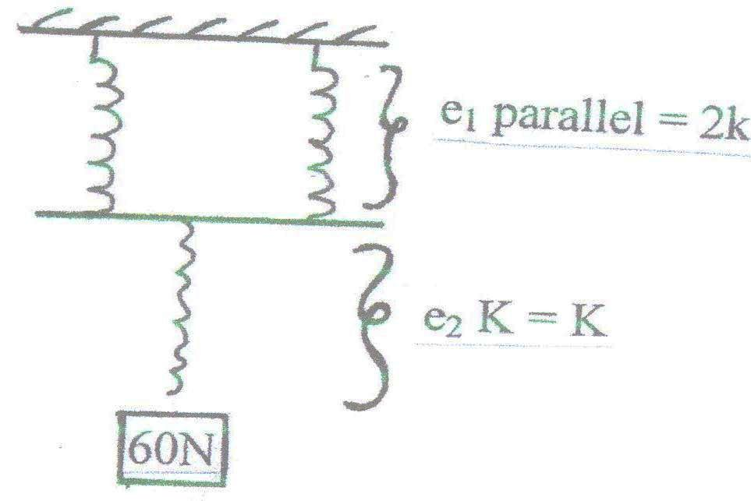

e1 + e2 = 6✓

e1 =

e2 =

=

= = 6

180 = 12K

K = 15N/cm✓

1. Balloon will expand, therefore Upthrust on the balloon increases,✓ thus clockwise moments increases more than anti clockwise moments✓.
2. Having a thinner capillary tube ✓
3. Gas inside the bottle expands, pushing the cork. ✓

The core expands more than the bottle hence becoming loose✓

1. a = $\frac{v-u}{t }$ = $\frac{0-30}{0.05}$**OR**  Ft = m4v

= $\frac{-30}{0.05}$ f =

= - 600m/s2 = = -12N

F = ma

= $\frac{20}{1000}$ $×$-600✓

= -12N

Retarding force = 12N✓

1. Iron gate when touched conducts heat away from the hand while wood does not because it is a poor conductor of heat ✓

**SECTION B**

1. a) Steam line flow where all the particles of the fluid move in the same direction at the same velocity at a particular point: ✓ Turbulent: particle moves with different velocities. ✓

b) The papers are observed to separate ✓ because of low pressure on the sides ✓A and B

c) A1V1 = A2V2

0.05 2.6 = 0.1 A2✓

A2 = = 1.3m2 **OR** 13000cm2

U sin g = A

= 13000

3.142r2 =

r2 = 4237

d = 2r

d = $\left(\sqrt{\left(r^{2}\right)}\right)$ $×$ 2

d = 128.65cm✓

d) i) Gas pressure✓

ii) 56mm Hg✓

iii) 760mmHg + 56mmHg = 816mmHg✓

1. (a) Surface tension of water is stronger than that of oil

(b) (i) Vol. = ✓

=

= 6.5476 x 10-5 cm3✓

(ii) A =

= ✓

= 176.786cm2✓

(iii) Vol. = ✓

h = ✓

= 3.7037 x 10-7 cm✓

(c) - Oil drop is perfectly spherical

- Size of oil molecule is same as thickness of patch.

- Patch is one molecule thick. (Max. 2 marks)

1. a) OA : object is accelerating

AB: object is accelerating gently and non-uniformly

BC: Object moving at constant speed

b) i) (I) u = 10m/s v = u + at

a = -2.5m/s2 = 10 – 2.5 1.5✓

t = 1.5sec = 6.25m/s✓

(II) s = ut + ½ at2

= 10 (1.5) – ½(2.5) (1.5)2 ✓

= 12.1875✓

= 12.19

(III) v = o v = u + at

o = 10 – 2.5t✓

t = $\frac{10}{2.5}$ = 45✓

ii)

V(ms-1)10

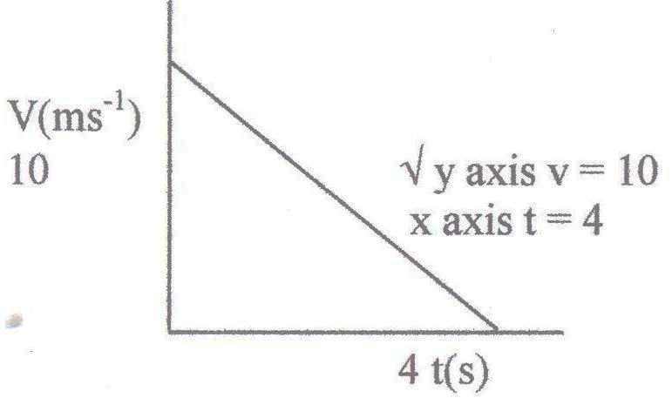

4

t(s)

10

iii) Distance = Area of triangle ✓

½ $×$ 4 $×$ 10

20m✓

|  |  |  |
| --- | --- | --- |
| 15.(a) | - A small force (effort) is used to overcome a large force (Load)  - Less energy is expended in doing work  - Less time is used in accomplishing the task | ✓2 for any two correct responses(2) |
| 15.(b)(i) | - In one revolution, both wheel and axle complete one circumference  - V.R = Effort Distance/Load distance = 2R/2r  - V.R = R/r | ✓1 mark for each bullet |
| 15.(b)(ii) | V.R = 50/5 = 10  M.A = efficiency x V.R/100 = 90x10/100 = 9  Effort = Load/M.A = 200/9 = 22.22N | ✓1 mark  ✓1 mark  ✓1 mark |

16.(a ) For an elastic material, the extension is directly proportional to the force producing it provided the

elastic limit is not exceeded. 1

e (cm)

F (N)

Wire

Coil

b (i)

(ii).The wire has a greater constant of elasticity 1 than material hence coil of the same greater gradient.

iii).

|  |  |  |  |  |  |  |  |
| --- | --- | --- | --- | --- | --- | --- | --- |
| Load | 0.00 | 1.00 | 2.00 | 4.00 | 5.00 | 6.00 |  |
| L | 10.00 | 11.50 | 13.50 | 16.00 | 18.00 | 24.00 |  |
| E | 0.00 | 1.50 | 3.50 | 6.00 | 8.00 | 14.00 | 1 |

iv) Suitable axes labelled 1

All points correct 1

Suitable line 1

v) Springs constant K = F 1

e

Use students graph

Correct units 1